Continuous Integration & Continuous Deployment Lab

EXPERIMENT – 11 (Vagrant)

**Name : Harivansh Mathur**

**Roll No : R171218043**

1. Installing Virtual Box

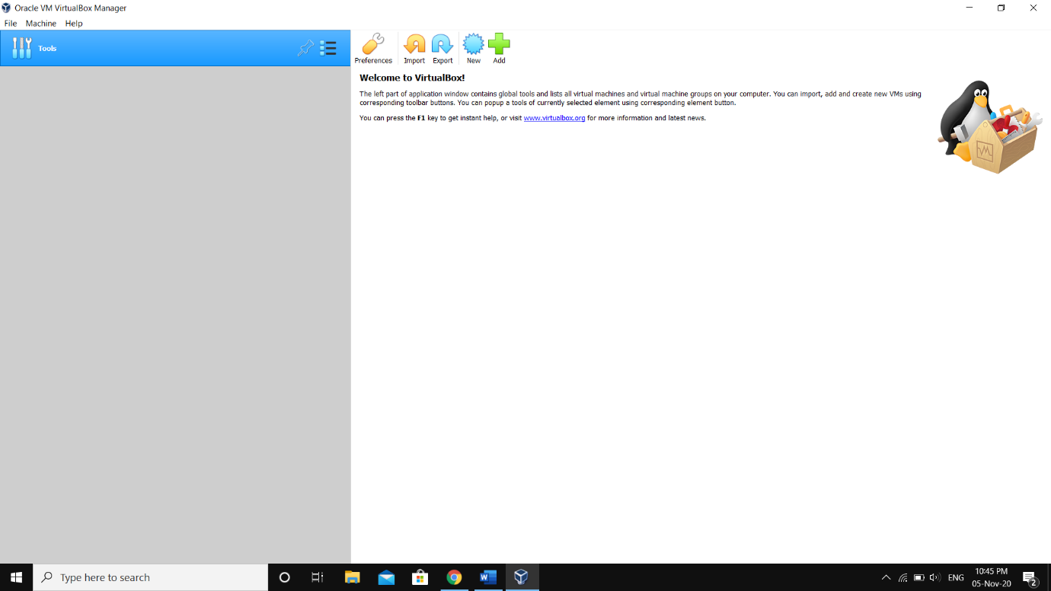

1. Installing Vagrant

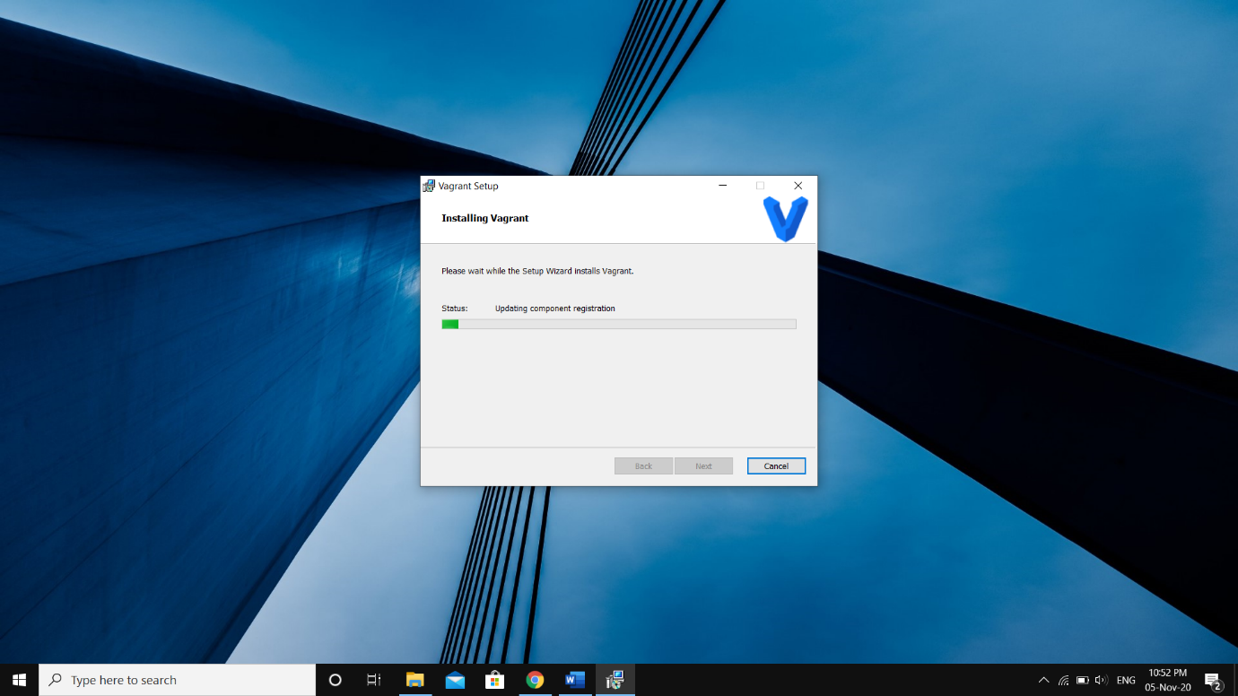

1. Making a new folder and initializing Vagrant in it

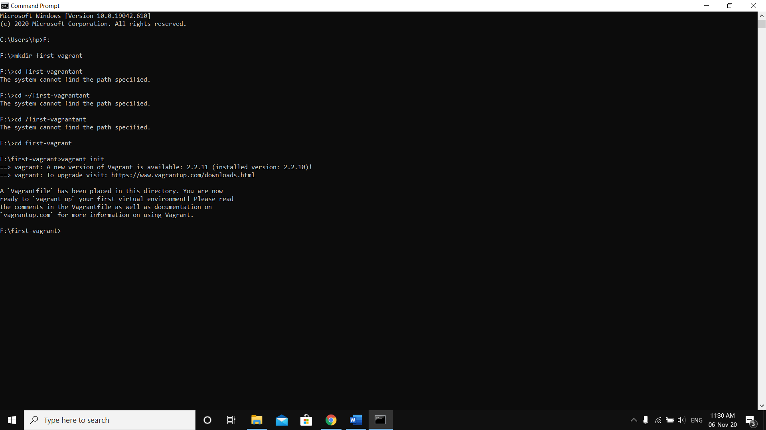

1. After vagrantfile is created changing vb.box from “base” to “ubuntu/xenial64”

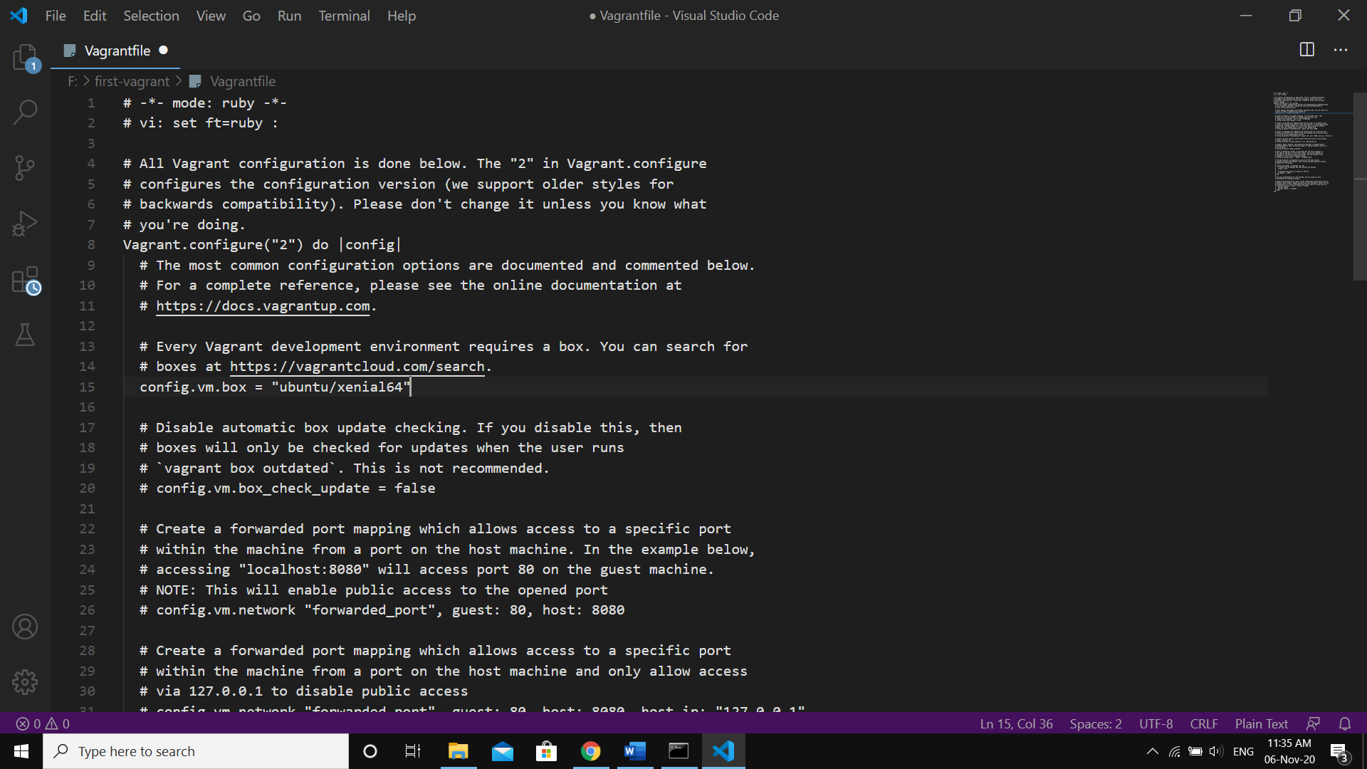

1. Downloading the VM image using **Vagrant up** command

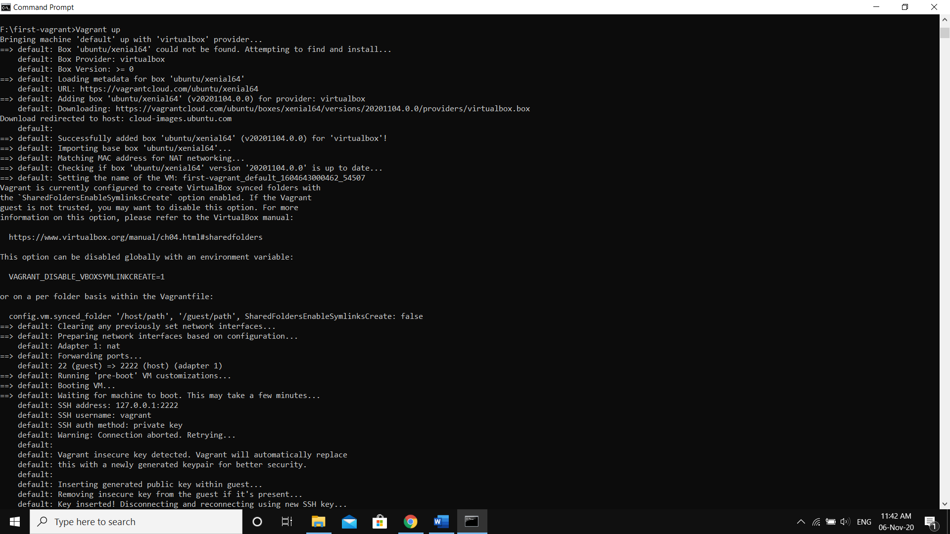

1. Starting the VM using **Vagrant ssh** command

